LAB 3
PROGRAM 3
Particle swarm optimization – Robotics path planning
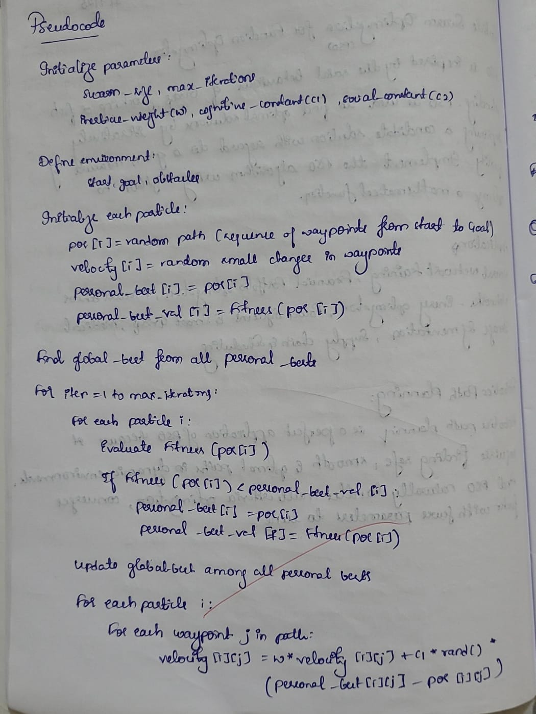

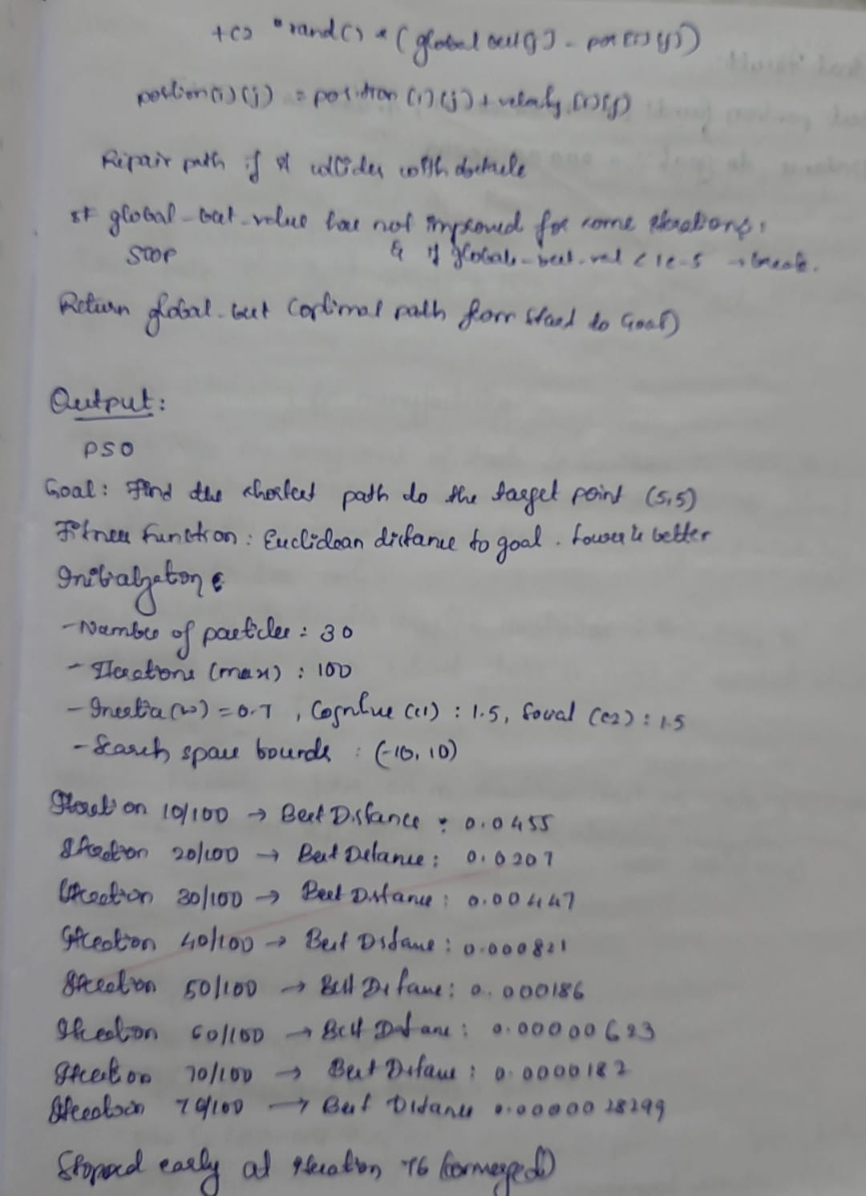

CODE:

import random
import math

# --- Particle Swarm Optimization for Robotic Path Planning ---
print("=== Particle Swarm Optimization (PSO) ===")
print("Goal: Find the shortest path to the target point (5, 5).")
print("Fitness Function: Euclidean distance to goal. Lower is better.")
print("Initialization:")
print("- Number of particles: 30")
print("- Iterations (max): 100")
print("- Inertia (w): 0.7, Cognitive (c1): 1.5, Social (c2): 1.5")
print("- Search space bounds: (-10, 10)")
print("========================================\n")

# Target point
goal = [5, 5]

# Parameters
num_particles = 30
num_iterations = 100
w = 0.7 # inertia
c1 = 1.5 # cognitive
c2 = 1.5 # social
bounds = (-10, 10)

# Fitness function = Euclidean distance
def fitness(position):
return math.sqrt((position[0] - goal[0])**2 + (position[1] - goal[1])**2)

# Initialize particles
particles = []
velocities = []
personal_best = []
personal_best_scores = []

for _ in range(num_particles):
pos = [random.uniform(bounds[0], bounds[1]), random.uniform(bounds[0], bounds[1])]
vel = [random.uniform(-1, 1), random.uniform(-1, 1)]
particles.append(pos)
velocities.append(vel)
personal_best.append(pos[:])
personal_best_scores.append(fitness(pos))

# Global best
global_best = min(personal_best, key=fitness)
global_best_score = fitness(global_best)

# Iterations
for t in range(num_iterations):
for i in range(num_particles):
# Update velocity
r1, r2 = random.random(), random.random()
velocities[i][0] = (w * velocities[i][0] +
c1 * r1 * (personal_best[i][0] - particles[i][0]) +
c2 * r2 * (global_best[0] - particles[i][0]))
velocities[i][1] = (w * velocities[i][1] +
c1 * r1 * (personal_best[i][1] - particles[i][1]) +
c2 * r2 * (global_best[1] - particles[i][1]))

# Update position
particles[i][0] += velocities[i][0]
particles[i][1] += velocities[i][1]

# Clamp within bounds
particles[i][0] = max(bounds[0], min(bounds[1], particles[i][0]))
particles[i][1] = max(bounds[0], min(bounds[1], particles[i][1]))

# Evaluate fitness
score = fitness(particles[i])
if score < personal_best_scores[i]:
personal_best[i] = particles[i][:]
personal_best_scores[i] = score

# Update global best
if score < global_best_score:
global_best = particles[i][:]
global_best_score = score

# Print progress
if (t+1) % 10 == 0 or global_best_score < 1e-5:
print(f"Iteration {t+1}/{num_iterations} -> Best Distance: {global_best_score:.10f}")

# Early stopping if close enough
if global_best_score < 1e-5:
print(f"\nStopped early at iteration {t+1} (converged).")
break

# Final result
print("\nFinal Result:")
print(f"Best position found: {global_best}")
print(f"Distance to goal: {global_best_score:.10f}")

OUTPUT:
